Move the SQL Tables into Azure Blob Storage by using Azure data factory.

Requirements:

1. Lookup activity
2. For each activity
3. Foreach activity inside the copy activity

Datasets:

1.SQL tables- by using SQL Server-lookup activity dataset.

2. All tables - by using SQL Server-copy activity source dataset

3. CSV tables- by using S-copy activity sink dataset

Need to have:

Parameters in Source copy activity

Table_Name & table_schema both are mapping into connection type

Paramater in sink data set

File name & add into dataset.

Finding all tables in the SQL Query:

select * from [internshipportal-sqldb-dev].INFORMATION_SCHEMA.TABLES where TABLE_TYPE='BASE TABLE'

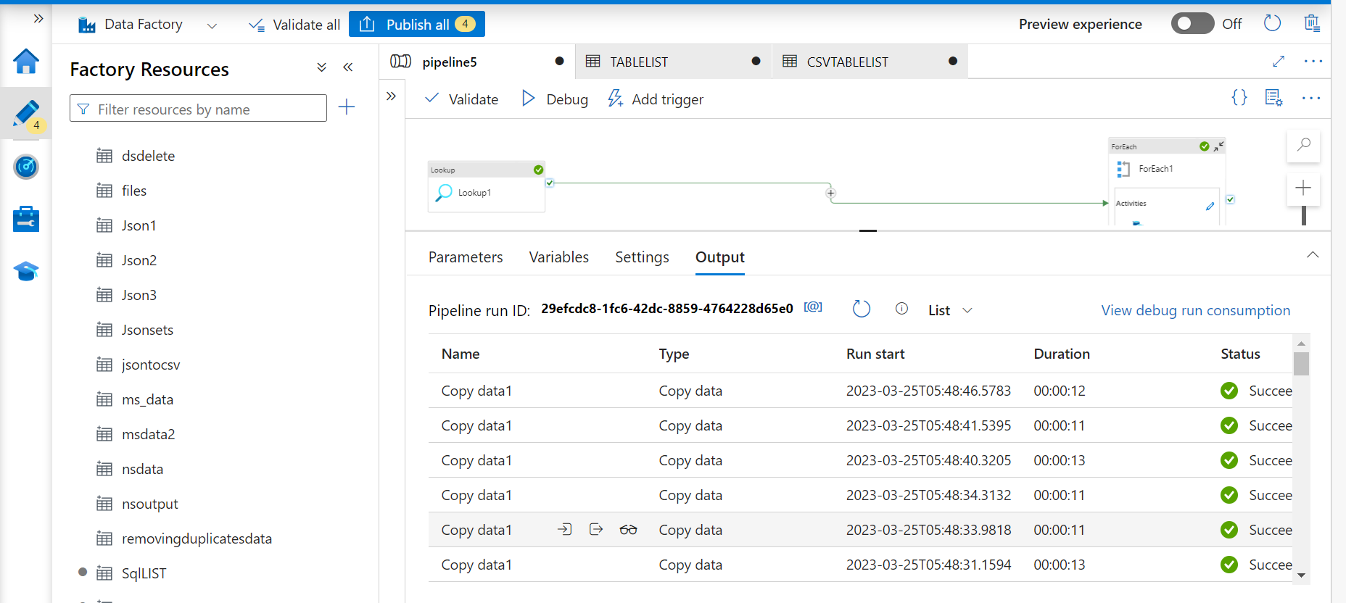

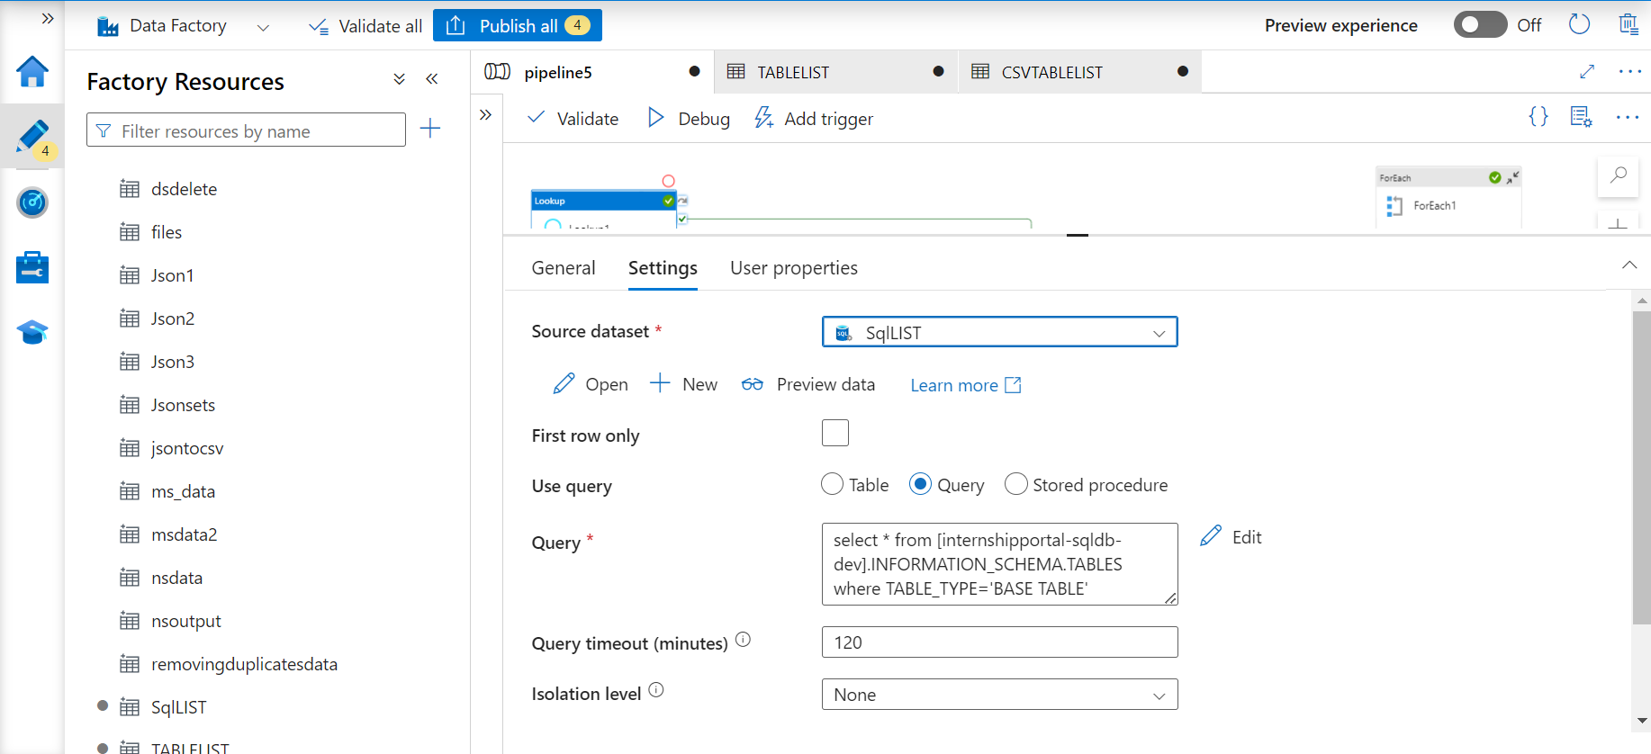

The Connection between Lookup & foreach activity must be success other wise throwing fail in the debug or trigger



